10/6/2017

@Akilan

When user presses Confirm in Reminder Details Page it leads to nowhere and does not save the changes. (Make it save the changes (okay I get that it cannot save) and lead to the Reminder Details Page with the changed information)

Akilan: Save changes can be done only when we go for server implementation using database.

For the Dashboard page, move the icons and the word at the very middle of each boxes.

Akilan: Corrected. Pease check and share

For the Start Work Page, there is an error when the user presses the restart button and then presses the Start button the Start Time will not change. When user presses the restart button then press the Start Button the Start Time should change into the current time the user pressed Start Button after pressing the restart button.

Akilan: Corrected. Pease check and share

Also, for the Start Work Page, the user should not be able to press the Done Button while working. User should only be allowed to press the Done Button after the Work is entirely finished(Done button should be allowed to press after user presses the Stop Button and confirm in the pop up that the Work is Done).

Akilan: Corrected. Pease check and share

Next, for the Start Work Page, Look at the image shared:

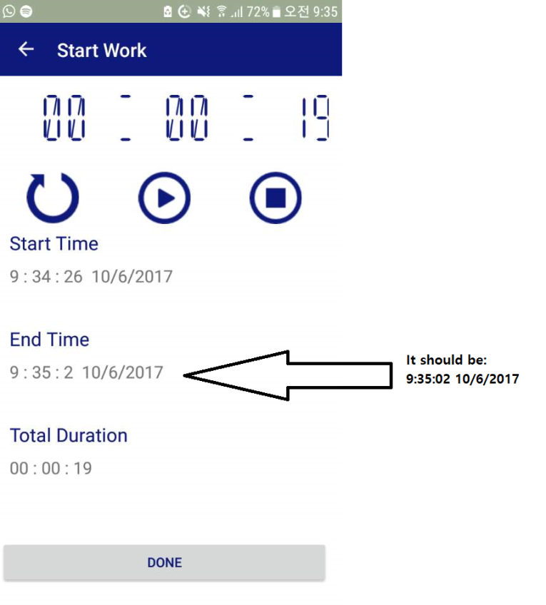

Akilan: Corrected. Pease check and share

The Scrolling option for the calendar is not very smooth, it is rough. Make it so that when user scrolls left and right to go to another month, the scrolling is smoother.

Akilan: We are using third party control with free library. If we want to change some features we have to go for paid. If you are interested to paid, I will share the paid link.

For the Side Menu(After pressing the hamburger button), I don’t like the orange highlighter. So, make the highlighter look exactly like this: (I only want the highlighting to change, nothing else)

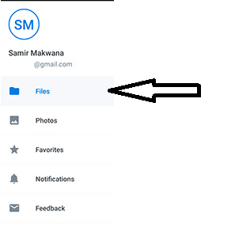

Akilan: I’m working on this I will update once I finished.

Will this be implemented later too?:

For the Calendar

* For example, if the user has a Booking Job on October 25th then below, it will show Booking No of that certain Job. Then user can press on that Booking No and it will lead to the Booking Details Page of that Booking. (Ex. Booking No 234, when user clicks on that in the calendar it will lead to the Bookings Details page of Booking No 234).

Akilan: It can be done when we going design to implementation process. Because we need to database for tracking user activities once they are logged in.